Ideation Phase
Empathize & Discover

Date | 31 January 2025
Team ID | 6AP3D7136F290BE8A6B32917
Project Name | AI FAQ ASSISTANT API
Maximum Marks | 4 Marks

Empathy Map Canvas:
An empathy map is a simple, easy-to-digest visual that captures knowledge about a user’s behaviours and attitudes.It is a useful tool to help teams better understand their users.
Creating an effective solution requires understanding the true problem and the person who is experiencing it. The exercise of creating the map helps participants consider things from the user’s perspective along with his or her goals and challenges.
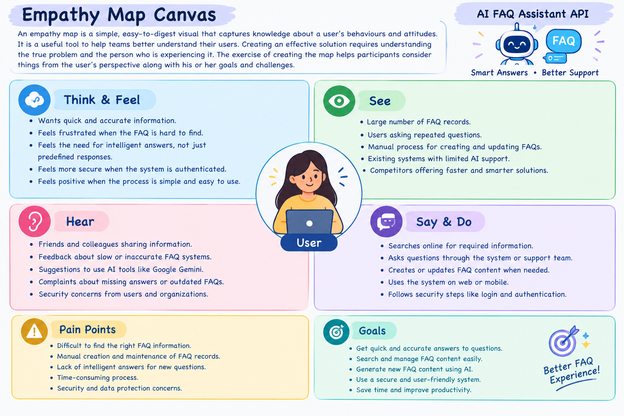
Example:
AI FAQ Assistant API – Empathy Map
Think & Feel
● Wants quick and accurate answers to frequently asked questions.
● Feels frustrated when the required FAQ information is difficult to find.
● Needs intelligent answers for questions that are not available in existing FAQ records.
● Wants a simple and easy-to-use FAQ management system.
● Feels more secure when authentication and password protection are provided.
See
● Large number of FAQ questions and answers.
● Manually created and maintained FAQ records.
● Difficulty in finding specific FAQ information.
● Existing FAQ systems with limited intelligent assistance.
● Need for faster and smarter question-answering solutions.
Hear
● Users asking repeated questions.
● Feedback about difficulty in finding FAQ information.
● Suggestions to use AI for generating answers.
● Complaints about outdated or missing FAQ information.
● Security concerns regarding user accounts and private FAQ operations.
Say & Do
● Searches for required FAQ information.
● Asks questions to obtain quick answers.
● Creates and manages FAQ records.
● Searches FAQs using keywords.
● Uses AI services to generate answers and FAQ question-and-answer pairs.
● Logs in and uses authenticated operations when required.
Pain Points
● Difficult to find the required FAQ information quickly.
● Manual creation and maintenance of FAQ records.
● Time-consuming process of preparing new FAQ content.
● Existing FAQ records may not contain answers to every question.
● Lack of intelligent answer generation.
● Security and unauthorized access concerns.
Goals
● Get quick and accurate answers.
● Search FAQ information easily.
● Create, update, and manage FAQ records efficiently.
● Generate new FAQ content using Google Gemini AI.
● Provide secure authentication using JWT.
● Protect passwords using bcrypt hashing.
● Maintain reliable and validated database information.
● Reduce the time required for FAQ management and answer generation.
Reference: https://www.mural.co/templates/empathy-map-canvas

